CS 531 Web Development Technologies

ASSIGNMENT 4

REPORT

By

Ravi Sai Sashank #258317

Divya Pavan Sai Alamuri #255562

**AJAX and Web Services**

Develop an application on your club web site using AJAX and Google map Web services. You may find the Google AJAX Search API sample code from <http://code.google.com/apis/maps/documentation/javascript/tutorial.html>.

We need to go to the URL mentioned above and register as a new user.

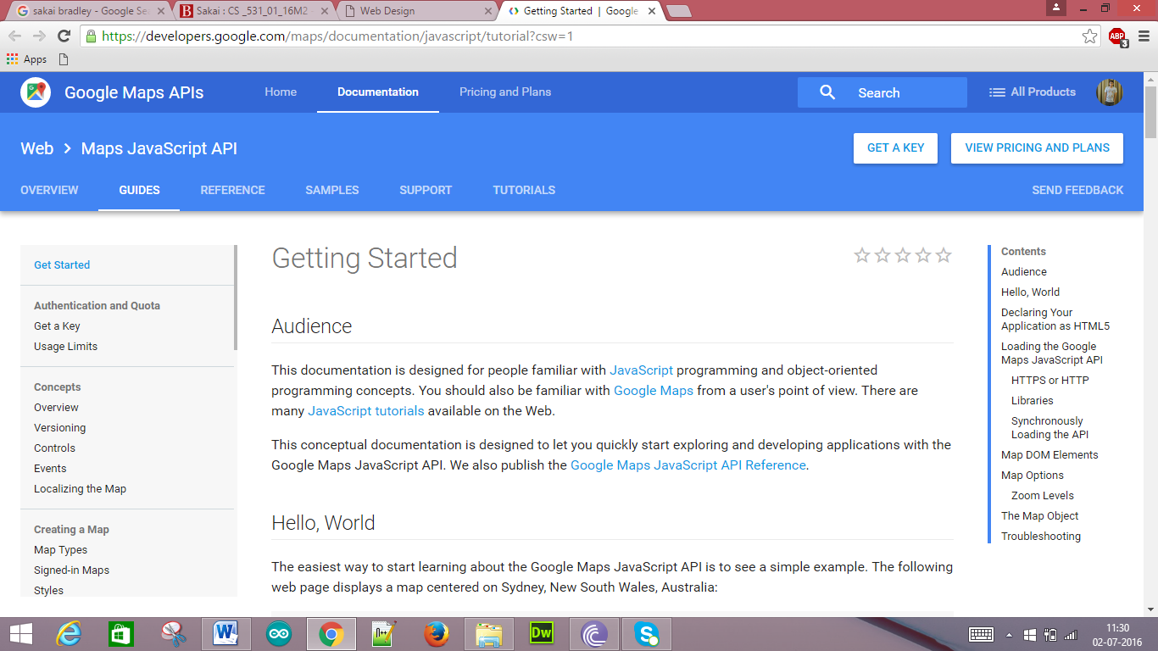

Click the “Get Key” which is present below Authentication and Quota and we get the following page.

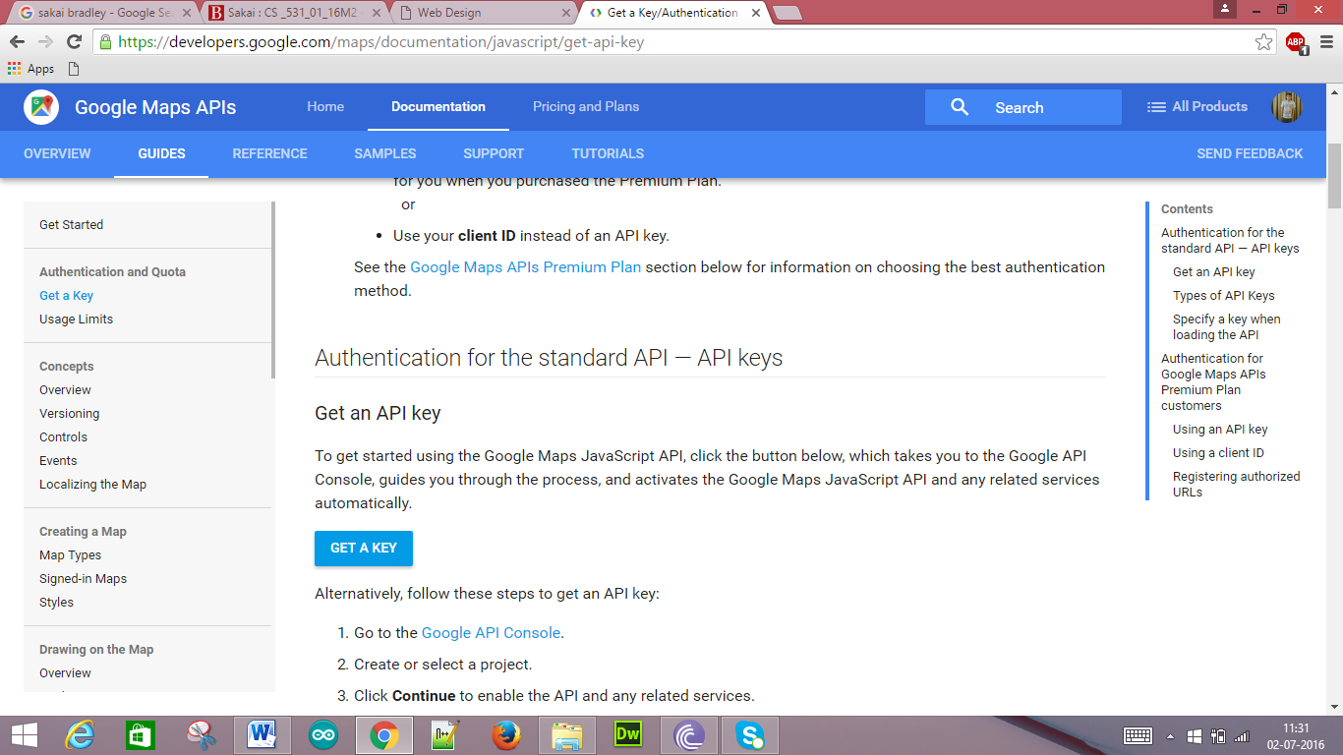

When we click the “Get Key” then we need to accept the Terms and Conditions in order to register.

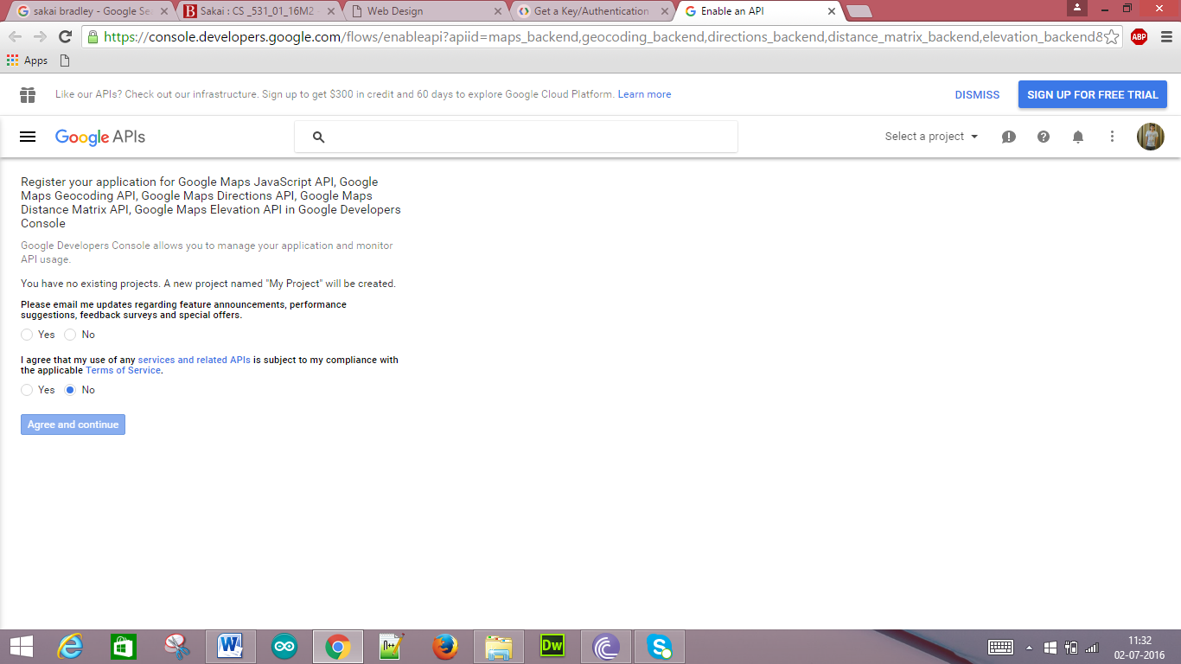

We need to enter the credentials in order to generate the API key.

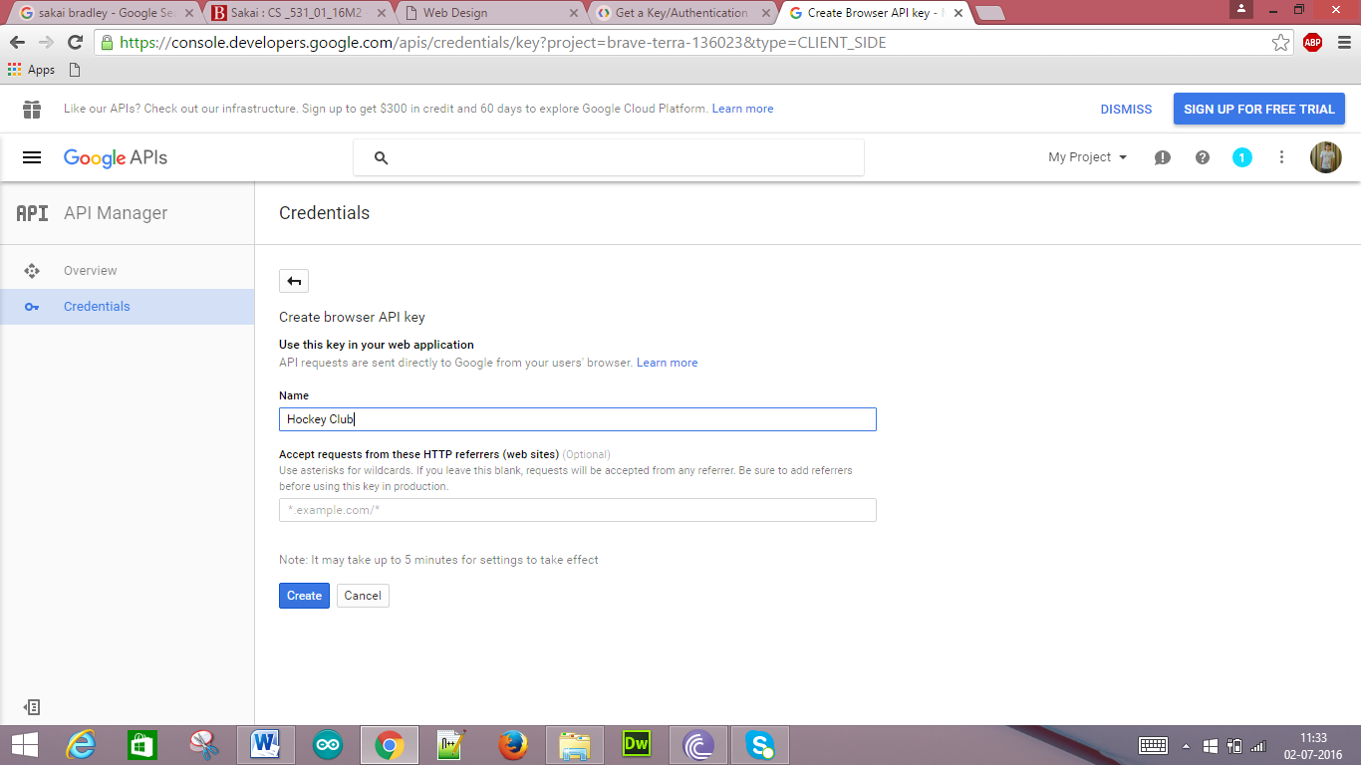

Then an API key is generated.

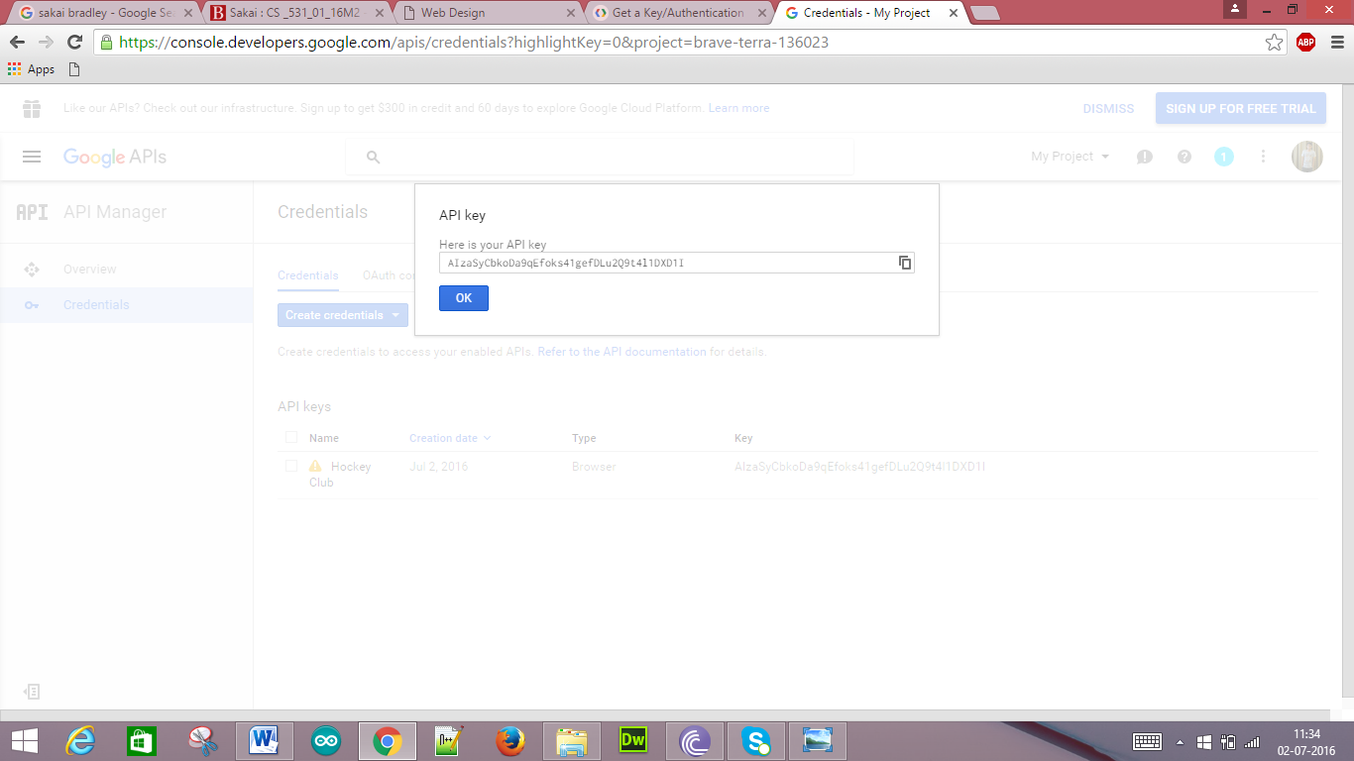

The below is the overview of the Credentials and API key.

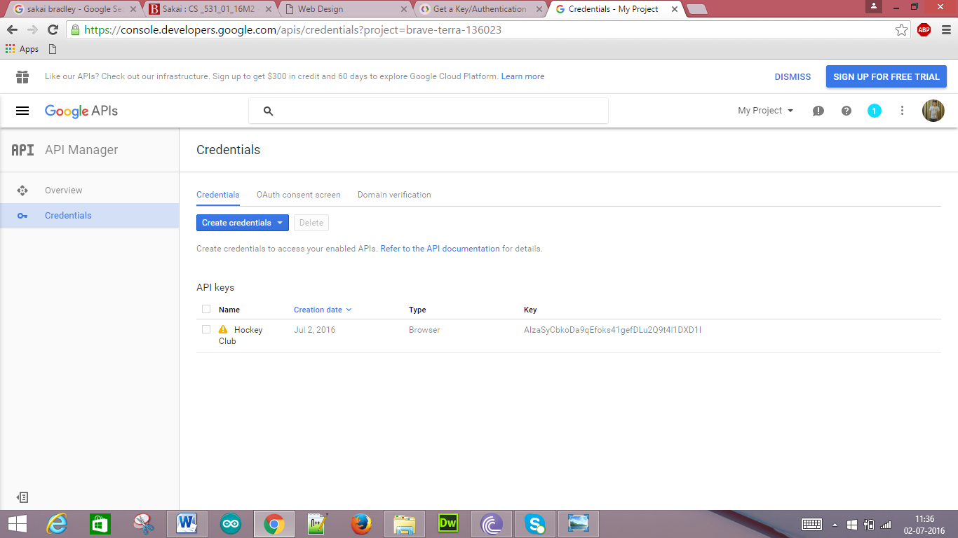

With the above API key we need to generate a Google Map using Ajax Web Services. So we have to create HTML file using Dream Weaver. The below shows creating a new HTML file.

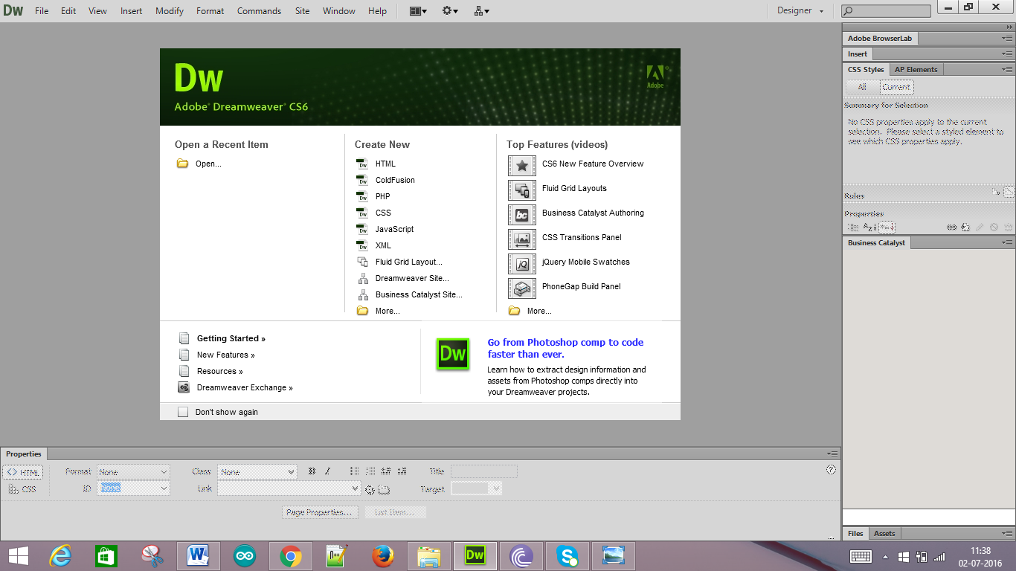

HTML code is as follows

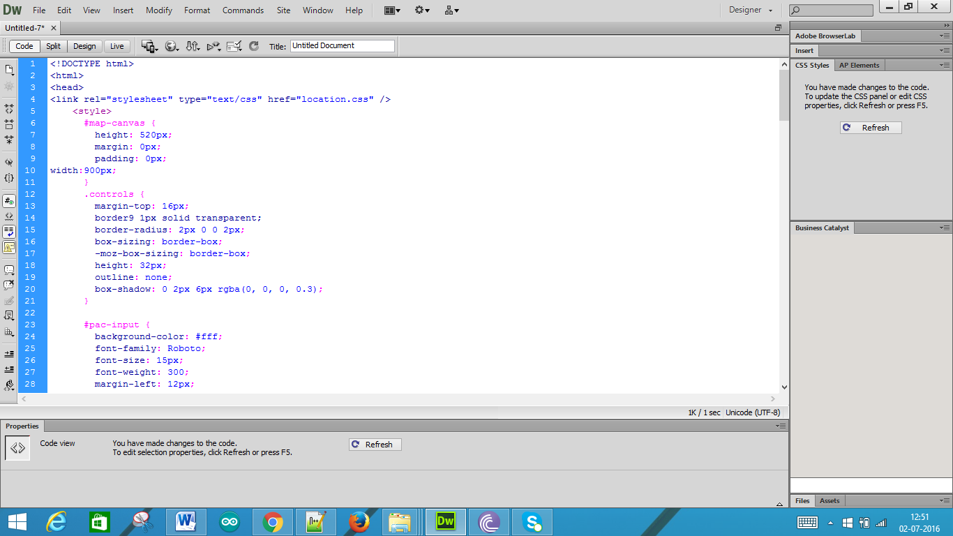

Save the above file as location.html

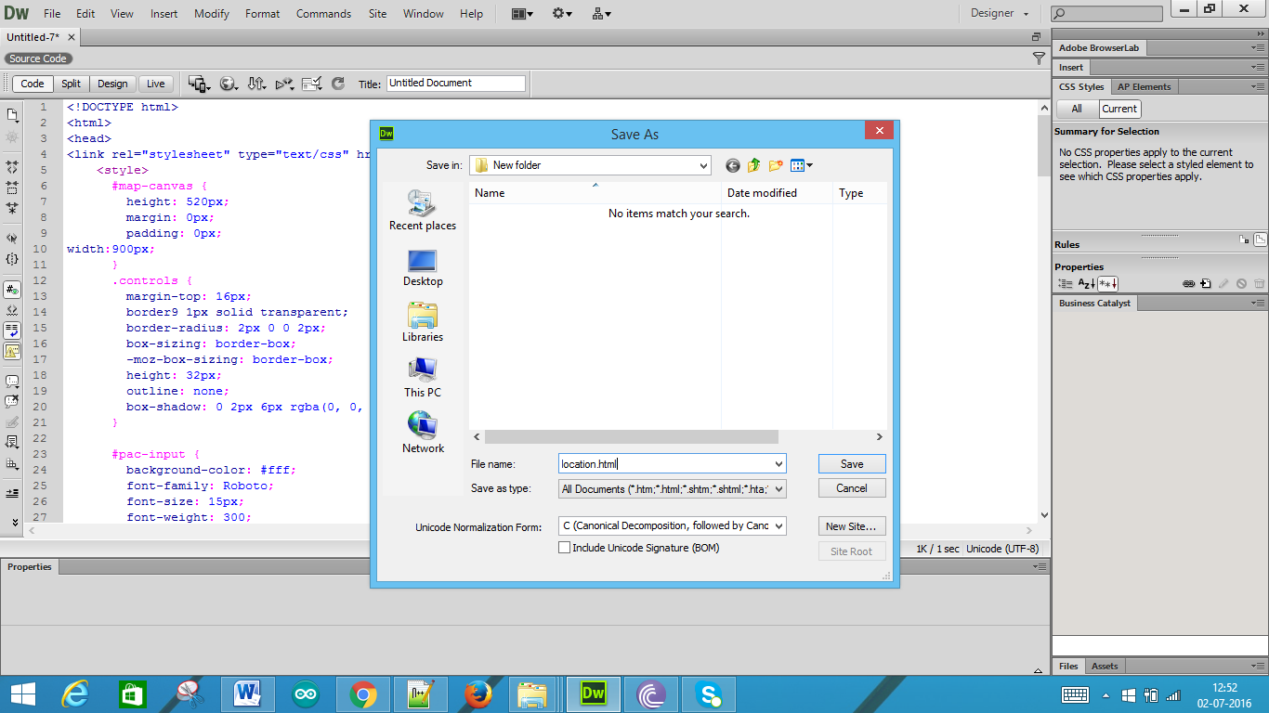

Now we need to create CSS file for styling the HTML page above

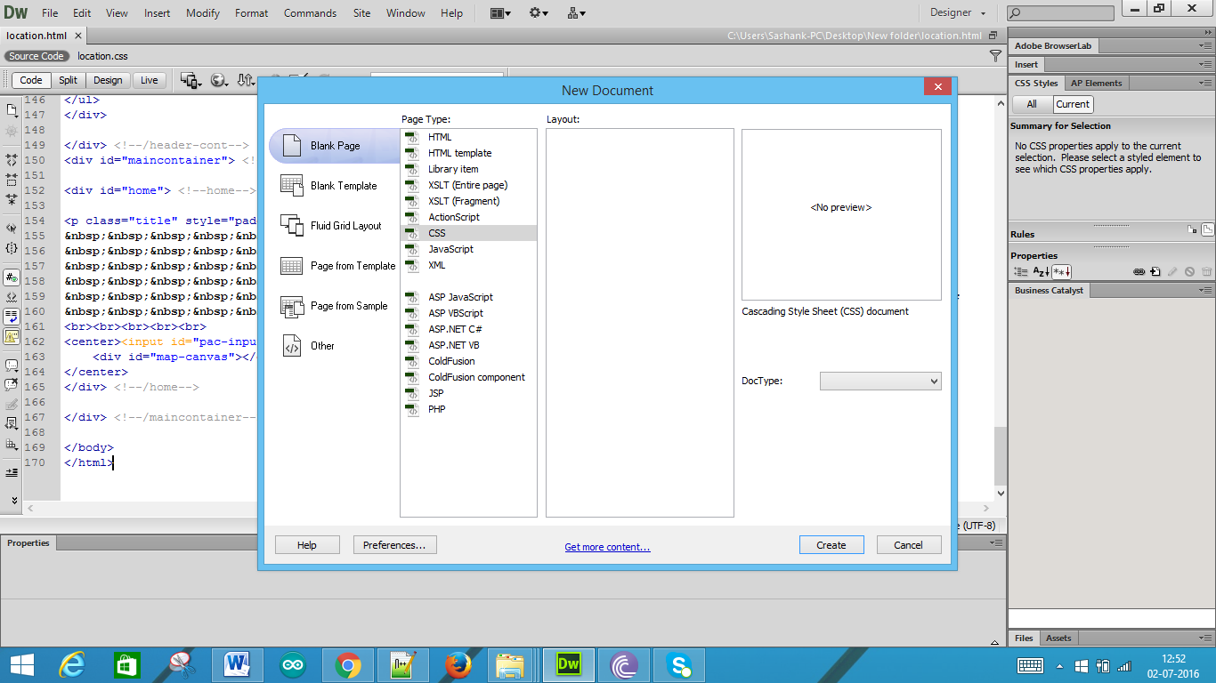

The below is the CSS code

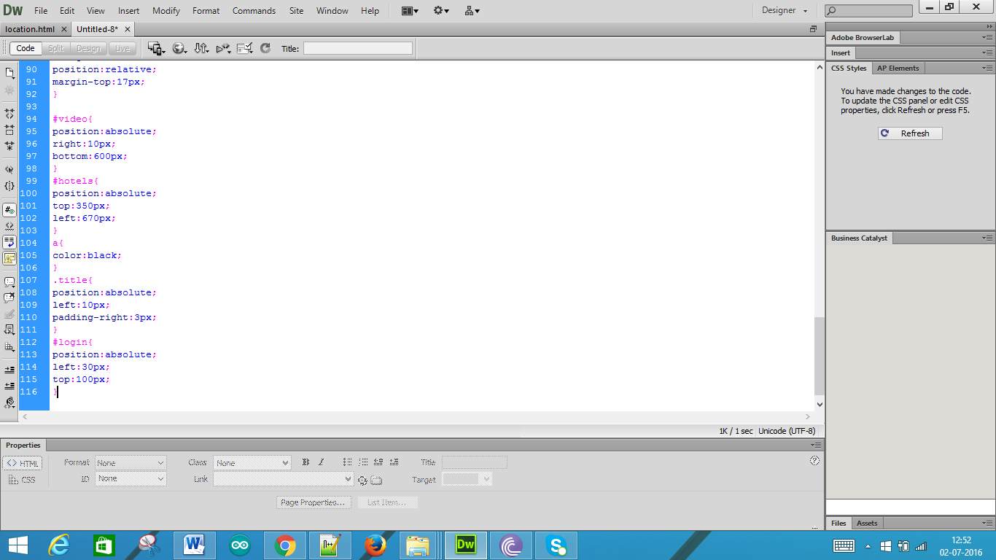

Save the file as location.css

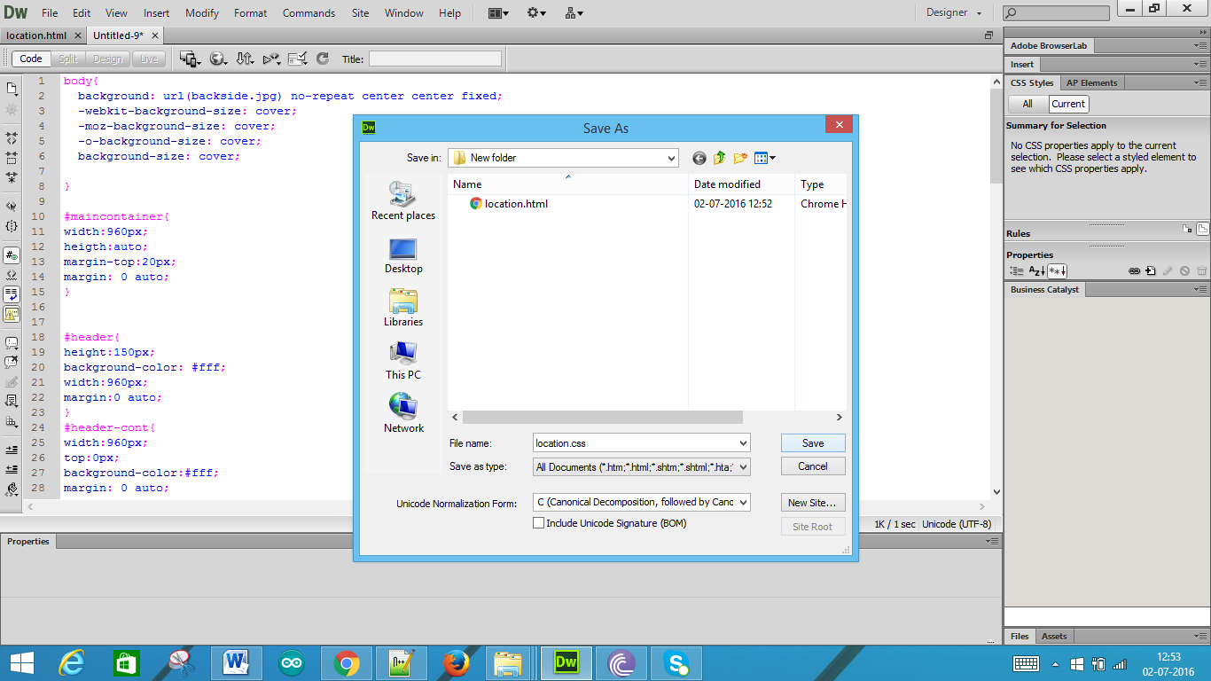

Now we need to create a map which is used to search places anywhere with one search box and div for map. Use places library to search for places.

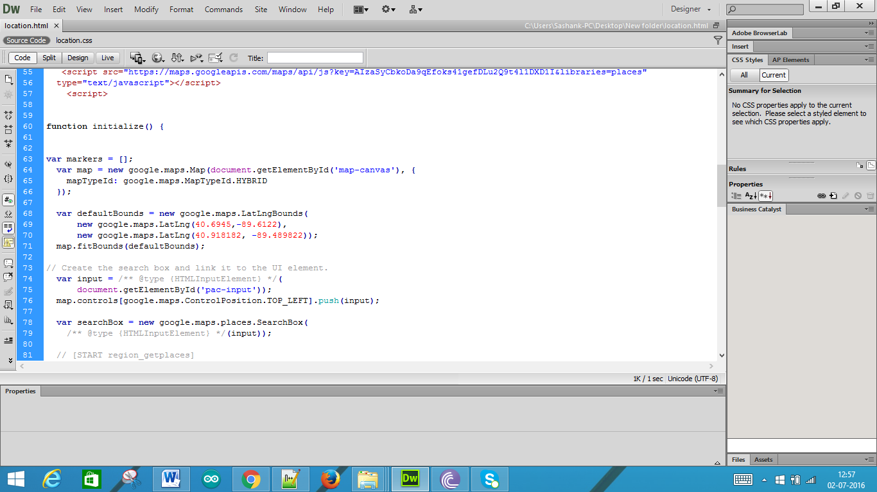

Below is the style sheet for the above HTML page.

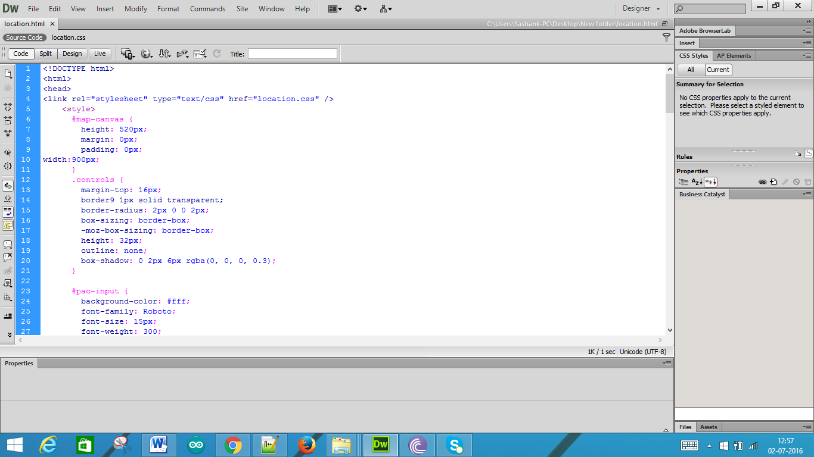

Now we can preview in the browser using the below option.

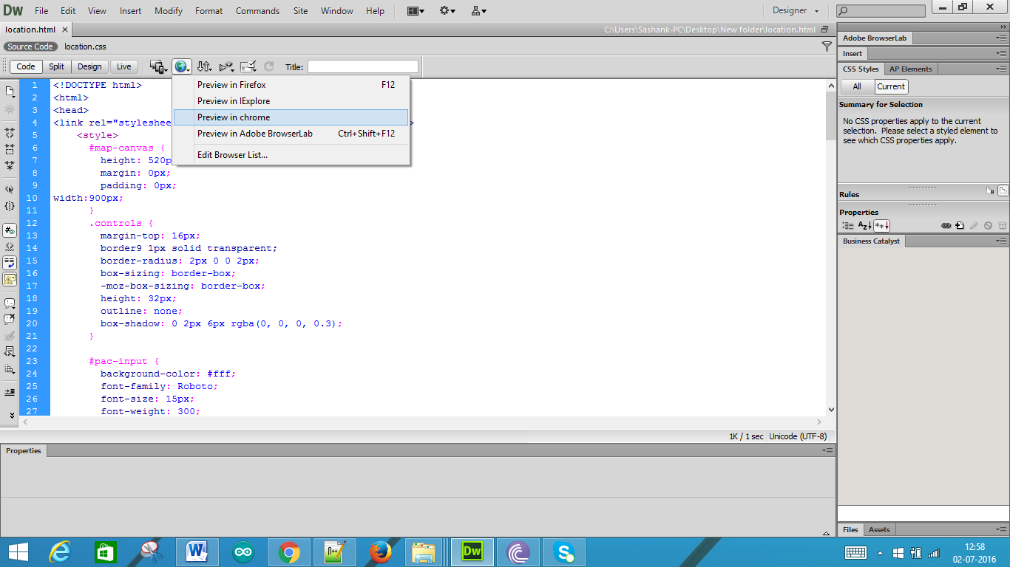

The output is as follows:

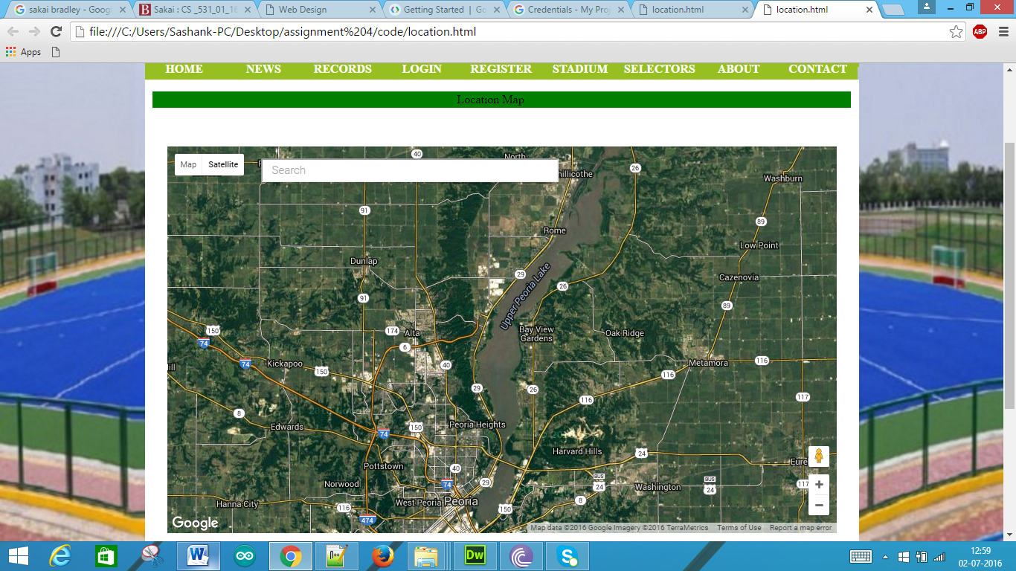

OUTPUT SCREENS:

Home page of the club is as follows with the “location map”

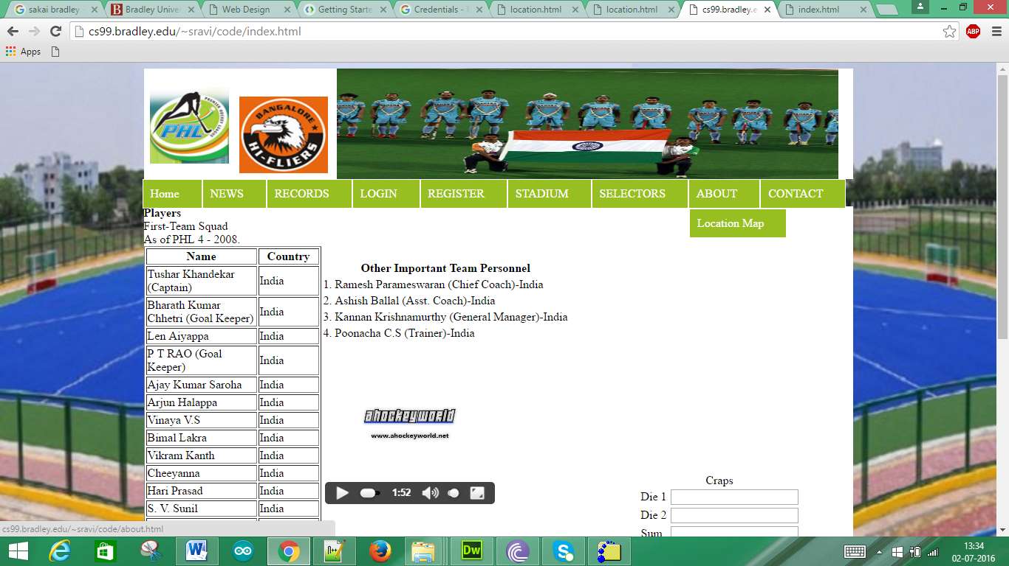

When we click the tab, we get the following satellite view of map as the Bradley Coordinates are default.

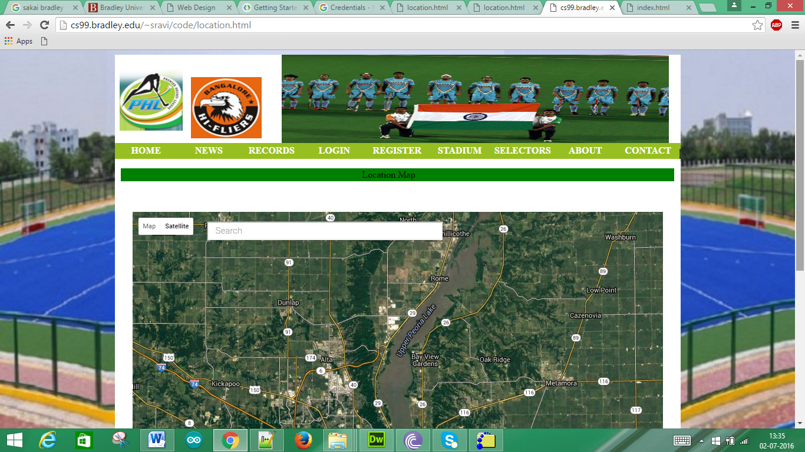

Search box also shows results when started typing.

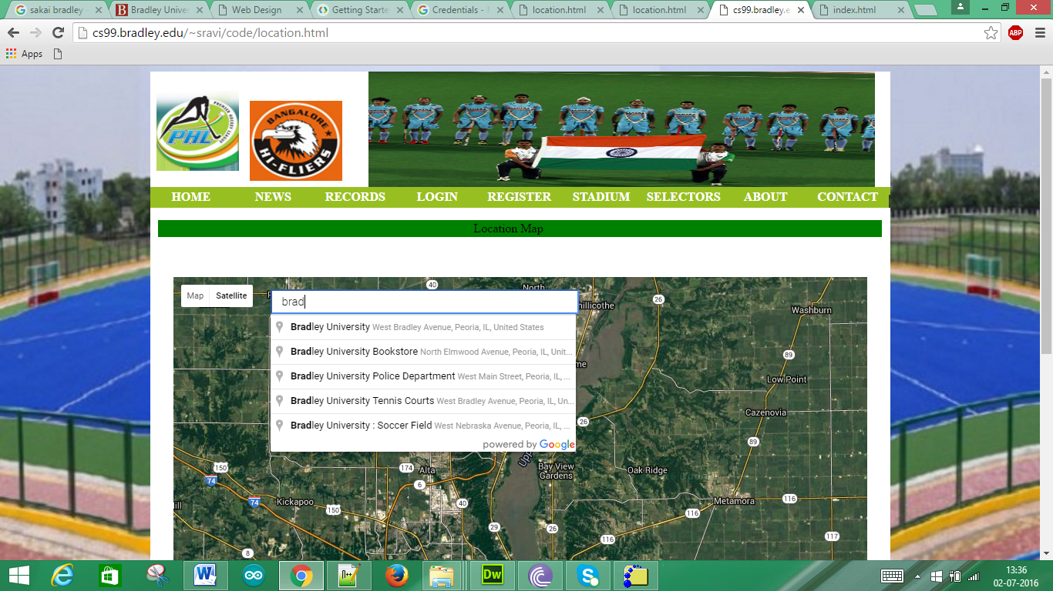

As the search is performed for Bradley University, The coordinates are obtained using geometry position. Then the location is changed in the map.

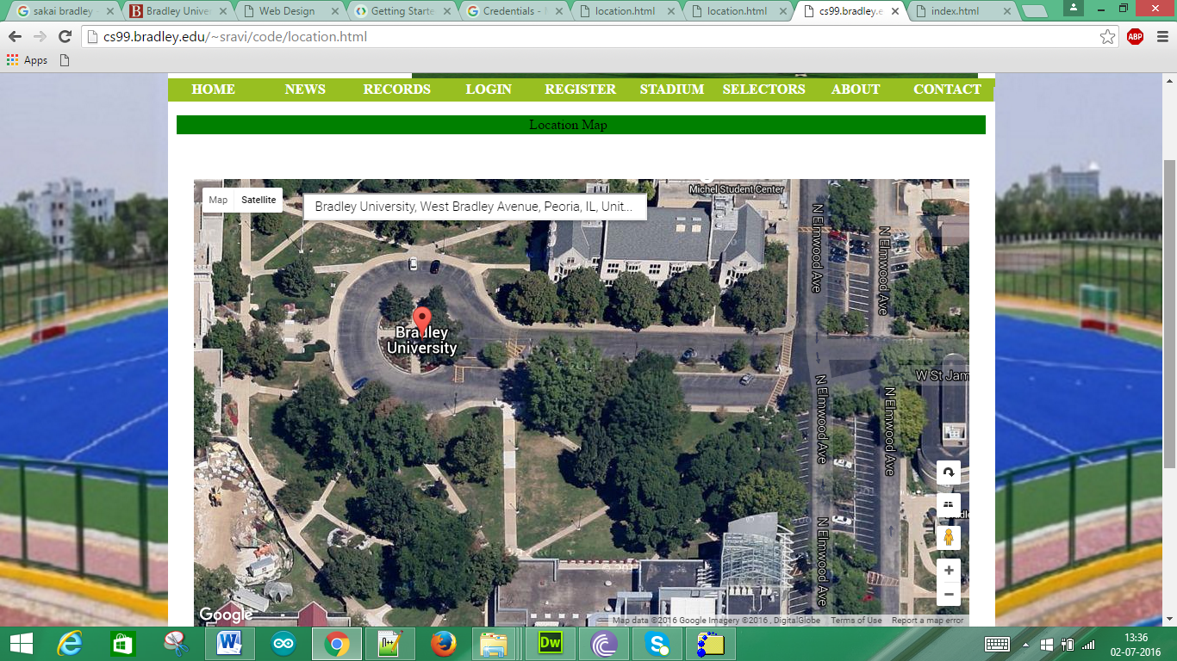

Below is the zoom out view of the above i.e., Bradley University.

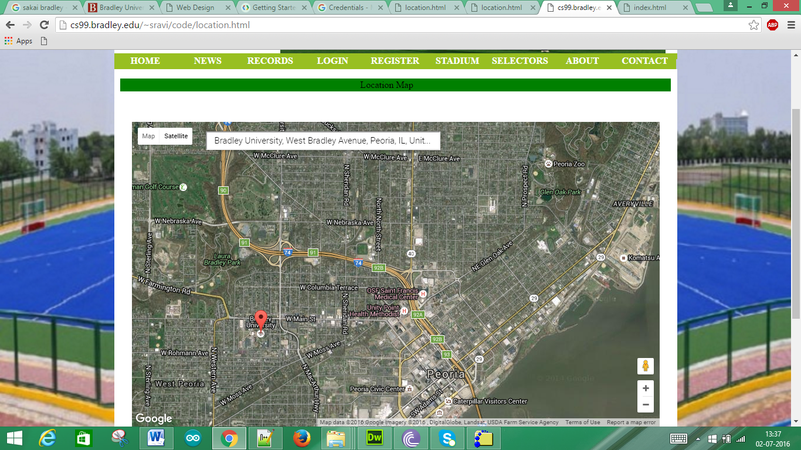

When we search for McDonald’s we get the following

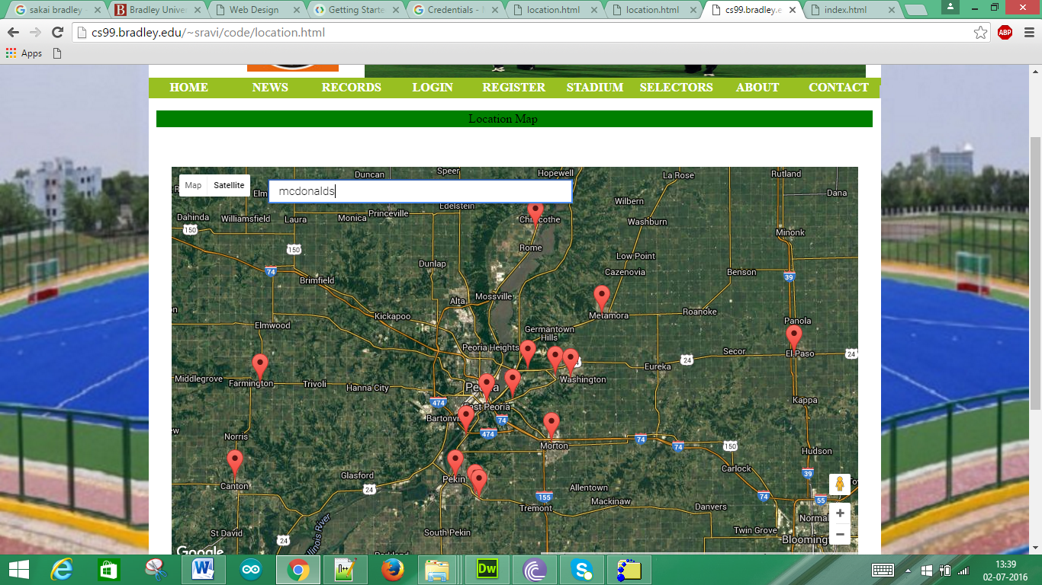

When we view above as map we get as following.

